**Laboratory of Analytical chemistry**

Lab. of the first stage

Date / /

**Experimental 3:**

**standardization of Sodium hydroxide (** NaOH**)**

Before starting to estimate the acid or Bases , we are assigned to obtain standard solution. The acids and bases commonly used cannot be used directly to prepare standard solutions because they are variable in composition.

For example:

HCl: Evaporate in high concentration

H2SO4: hygroscopic

HNO3: Evaporate and dissociate

NaOH, KOH, Ca(OH)2: are very hygroscopic

2NaOH + CO2 Na2CO3 + H2O

Ca(OH)2 + CO2 CaCO3 + H2O

NH4OH NH3 + H2O [Evaporate and changing in concentration]

**Procedure:**

1-Weigh 4 gm of NaOH and dissolve it in one liter distilled water.

2- Transfer 10 ml of standard HCl solution to a conical flask.

3- Add 1-2 drops of phenolphthalein (ph.ph) as an indicator.

4- Fill the burette with the prepared NaOH solution.

5- Add NaOH drop by drop into the conical flask until the color of the solution is faint pink.

6- The exact normality of NaOH is obtained from:

HCl + NaOH NaCl + H2O

N1V1(NaOH) = N2V2(HCl)

**Titration curve:**

This is very similar to the previous curve except, of course, that the pH starts off low and increases as you add more sodium hydroxide solution.

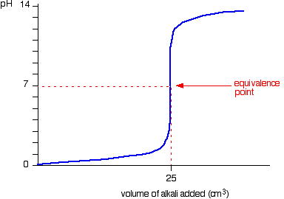

Again, the pH doesn't change very much until you get close to the equivalence point. Then it surges upwards very steeply.

**Lecturer**

Hussein N. K. AL-Salman